WORLD LANGUAGES: Level IV Proficiency Tracker/Self-Assessment
Proficiency Goal
Novice
High
Intermediate
Low
Intermediate
High
Intermediate
Low
Intermediate Mid
Novice
High
Advanced
Mid
Advanced
Low
Intermediate
Mid
Check off your proficiency level based on the Holistic Rubric.
Proficiency Progress
CB- Choice Board R-Reading L-Listening W-Writing S-Speaking T: Teacher Assignment
 | THEME: |  |  |  |  |  | THEME: |  |  |  |  |  | THEME:
 | CB CB CB CB T T  L R W S W S |  |  |  |  |  | CB CB CB CB T T  L R W S W S |  |  |  |  |  | CB CB CB CB T T  L R W S W S
Novice High
Intermediate
Low
Intermediate Mid
Intermediate High
Advanced Low
Advanced Mid
THEME:
____________________

THEME:
____________________

THEME:
____________________

Learning Reflection
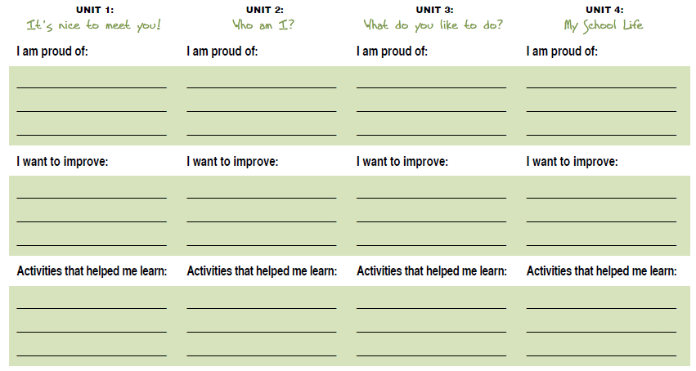
THEME:
____________________

Self-Reflection Proficiency Tracker
For this self-reflection, shade your proficiency level. Use the appropriate World Language rubric to justify your decision.

Self-Assessment by Theme: ________________________

Assignment
Name

Novice High
Intermediate
Low
Intermediate Mid
Intermediate High
Novice Low
Pre-Novice
READING LISTENING WRITING SPEAKING

What was your average Proficiency Level in the products you produced in this Theme?
Novice High Intermediate Low Intermediate Mid Intermediate High Advanced Low
Why did you score yourself at this particular level? (Use evidence from the rubric to support your score.) __________________________________________________________________________________________________________________________________________________________________________________________________

What can you do to “bump” your Language Proficiency skills up a notch? _________________________________________________________________________________________________

What can I do as your teacher to help you improve your Language Proficiency skills?
_________________________________________________________________________________________________

NOTES/COMMENTS:

