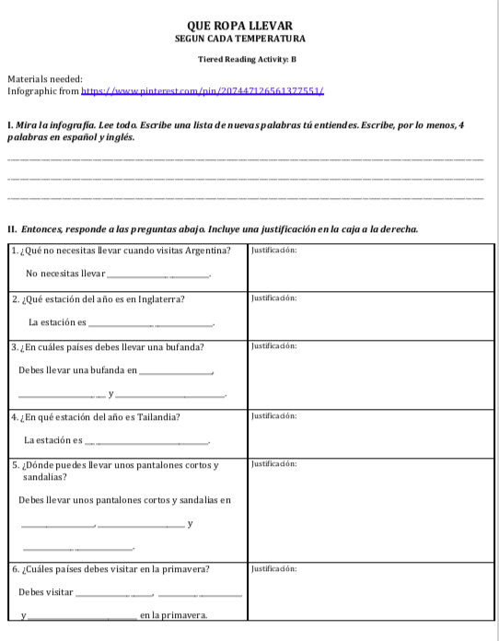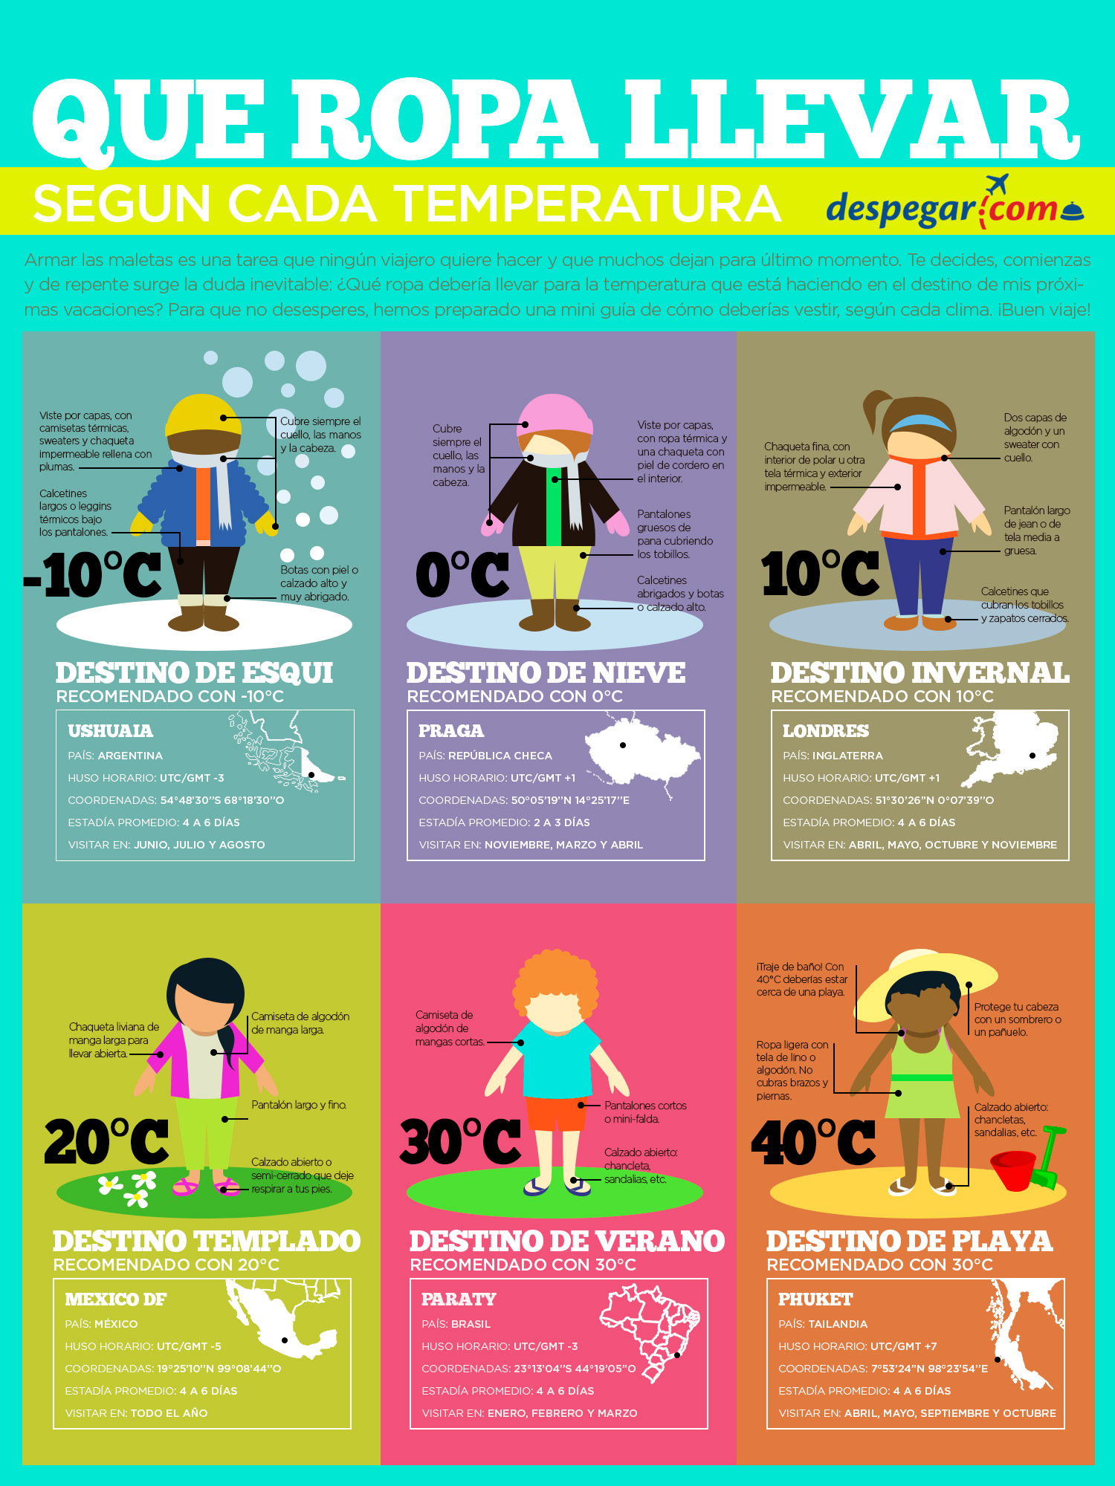

**Reading/Writing Station: Clothing**

**Que ropa llevar**

Read the infographic entitled “Que ropa llevar” and complete the activity sheet. Select a tiered reading activity (A, B, or C ) based on your readiness level.