Reading Station: Daily Routine

Read the infographic, “Un día dn la vida de un estudiante.”

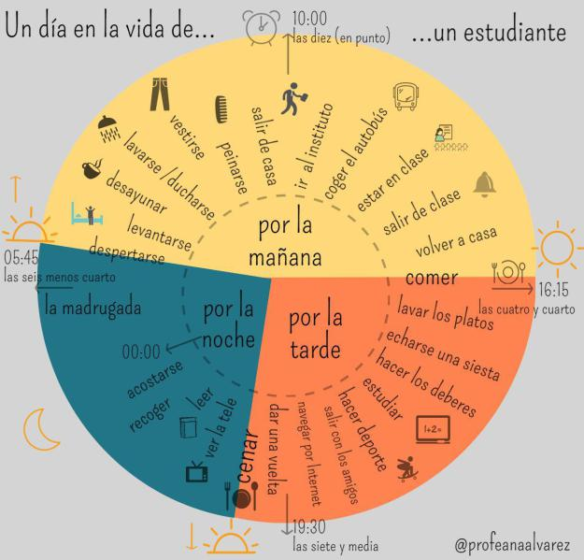

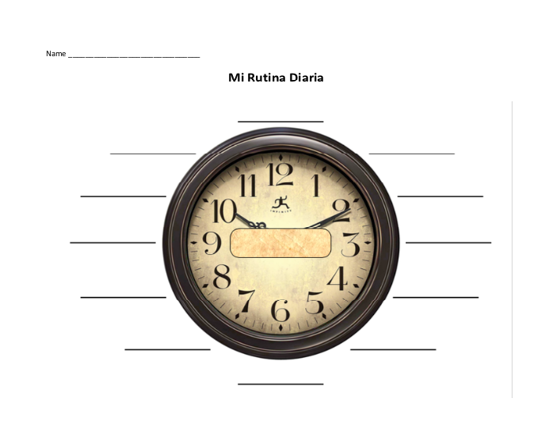
Using the blank clock provided, create one that reflects your daily routine. You do not have to use all of the expressions from the infographic and may add some of your own. Because you are talking about yourself, be sure to use the “yo” form of the verbs.

