Writing Center: Describing People

Using the two memes, called “Soy única” and “Pequeñas Cosas” as a guide, create a similar one about yourself.

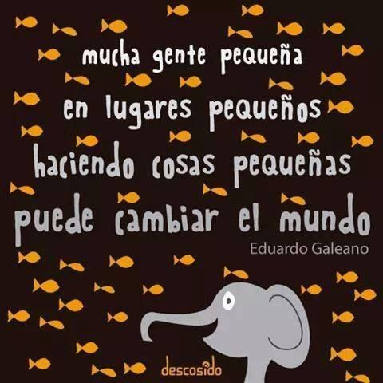
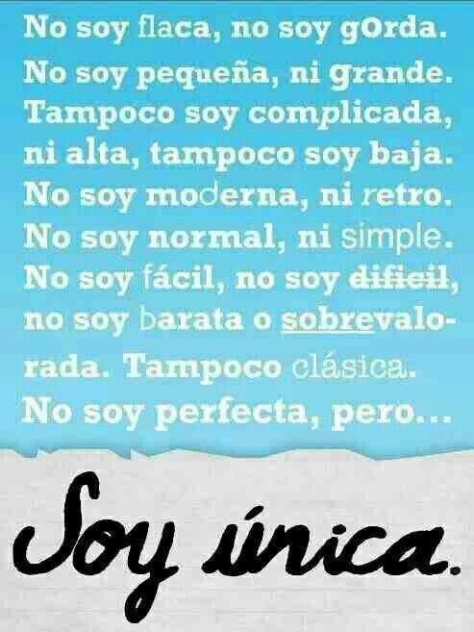

If needed, you may use your vocabulary list as a support.

