Speaking Center: Describing People

Select one character from either the Big Bang Theory or the Monsters Inc. infographic. Do not tell your teammates which character you chose. Give clues to your teammates about your person. Your teammates will try to guess which character you are describing.

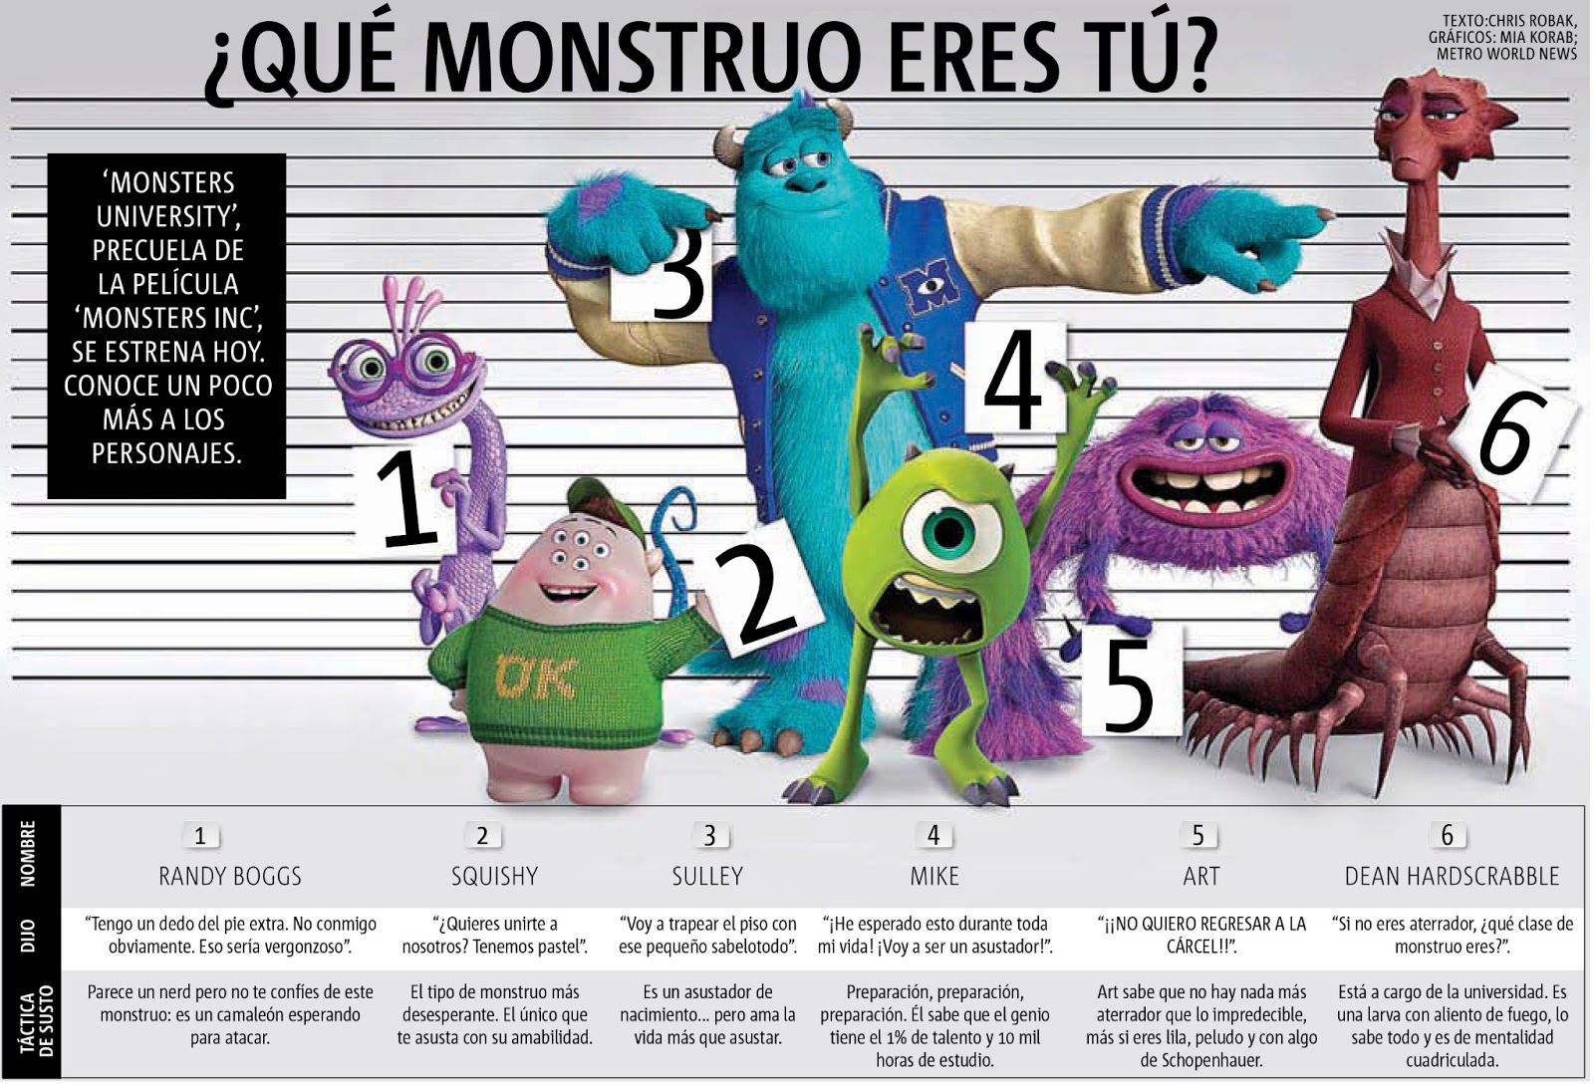
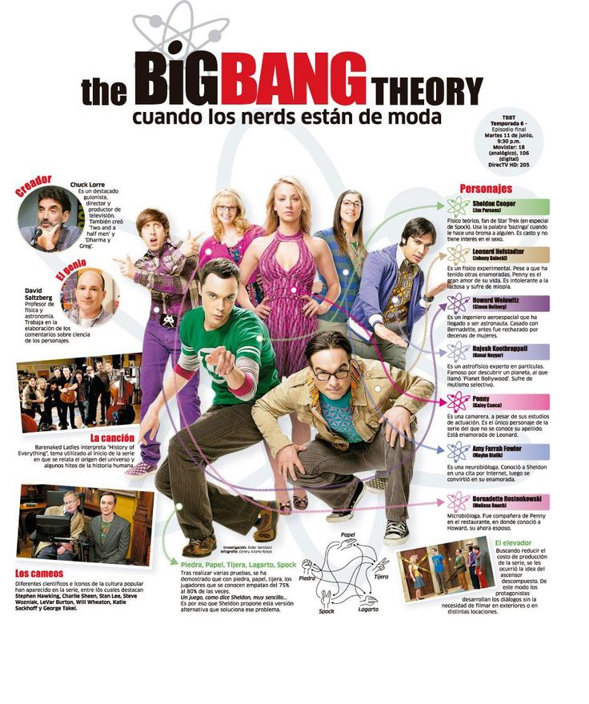

You may choose to use the sentence frames and expressions below to create your clues:

El/Ella es (no es) ___________________
El/Ella es una persona que _______________
El/Ella es ________ como ____________
El/Ella tiene (no tiene) _______________

muy
un poco
también

