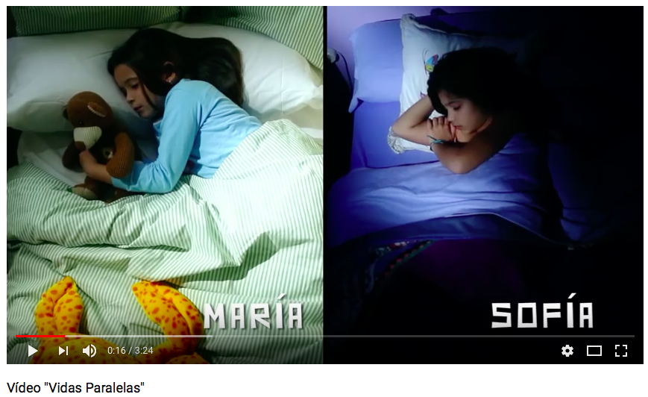

<https://www.youtube.com/watch?v=Q4aZ433R_Pk>

**Listening/Viewing Station: Daily Routine**

**Las Vidas Paralelas de María y Sofía**

Select the tiered listening activity (A, B, or C ) based on your readiness level. Watch the video and complete the activity page.