Before Reading Choice Board

Before you read your book, choose one of the following to show your pre-knowledge of the text.
Je m’appelle: _________________________________

Prédiction Organisateur  Using the title, subtitles, & images to predict what the text will be about using the prediction template.  Date complétée: ___________ | Connections personnelles  Before reading, write some ideas or personal experiences relating to the title. Complete the template “Connections personnelles.”  Date complétée:___________ | Brainstorm Clouds  Before reading, write any ideas or questions you have on the topic on the Brainstorm Clouds template.  Date complétée: ___________
Mon Thermomètre  Shade in the part of the gauge that shows your understanding before after reading the text.  Date complétée: ___________ | K W L(SVA)  Complete the K and W columns on the template before you read. Complete the L after reading.  Date complétée: ___________ | Peer Prediction Discussion  Write your predictions, share with a partner. Write a partner prediction. Use Peer Discussion template.  Date complétée: ___________
Écrémage(Skimming)  Before you read, skim the text using the Skimming template.  Date complétée: ___________ | Anticipation  Look at the images and write a few sentences in French about what is going to happen. Check true or false before reading and check after reading.  Date complétée: ___________ | My questions  Good readers ask questions before, while and after reading. Write 3 before reading questions about the text on template QUESTIONS et PISTES(clues).  Date complétée: ___________
Vocabulary Before and While reading
Everyone has to complete this activity after completing one of the above.
While reading, complete the vocab list. 1) try to understand the words using: images, cognates, context, prefix or suffix knowledge.
After reading the text, check your vocabulary predictions.

Date complétée: _____________ _________________ ________________ ______________

Avant(before) la lecture: la prédiction et discussion entre camarade (Peer prediction)

Directions: Avant de lire le texte, écrivez des prédictions sur l’organisateur. Partager(share) avec un/une camarade et écrivez les idées.

Titre: / Thème: _________________________________________________________________

Mes idées  Écrivez votre prédiction sur le texte.  (Regardez: le titre, les images..) | Les idées de mon/ma camarade  Parlez et écrivez la prediction de votre camarade | Mes liens  What did you learn from your partner’s predictions? Explain whether you agree(Je suis d’accord) with their predictions.
Avant la lecture: Faire un << brainstorming >> dans les nuages(clouds)

Directions: Write the title or topic in the center cloud. Before you read, write any ideas or questions you have about the topic or book in the surrounding clouds.

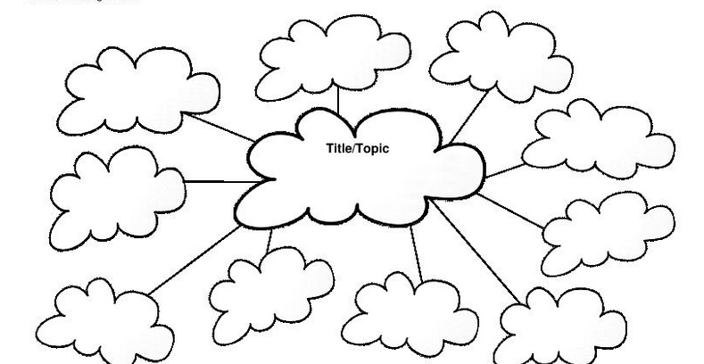
Titre

Avant la lecture: KWL (SVA)
S - Savoir V – Voulez savoir A - Appris
Directions: Complétez les colonnes K et W avant(before) de lire. Après(after) la lecture complétez la L.

Titre/Sujet : _______________________________________________________________________

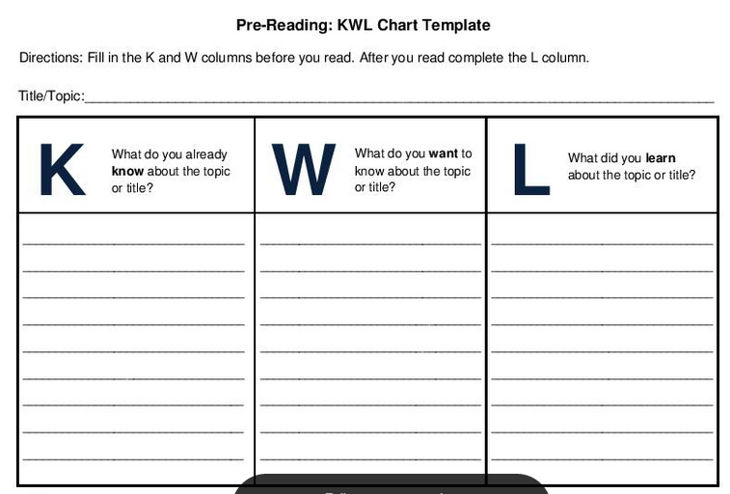
Faites la liste de ce que vous avez appris (LEARN) lors de votre lecture ou après.
Faites la liste sur ce que vous voulez (WANT) savoir(to know) sur le sujet.
Faites la liste de ce que vous savez (KNOW) sur le sujet avant la lecture.

Écrémage(skimming) de la lecture

Instruction: Avant de lire, survolez tout le texte sans le lire mot par mot (skim over the whole text without reading every word). Faites attention au texte, comme les images, et le titre. Complétez l’organisateur graphique.

Titre/ Thème : ___________________________________________________________________________________________________

Qu’est-ce que vous a remarqué ?  What stood out ? | Pourquoi c’est important ?
1.
2.
3.
4.
5.
6.

Écrivez une prédiction sur le texte utilisant vos remarques. (Write a prediction about the text based on what stood out to you.)
Prédiction : Connections personnelles

Instructions: Avant(before) de lire, écrivez des idées ou des expériences de votre(your) vie(life), dont(that) le titre ou le theme vous faites penser.

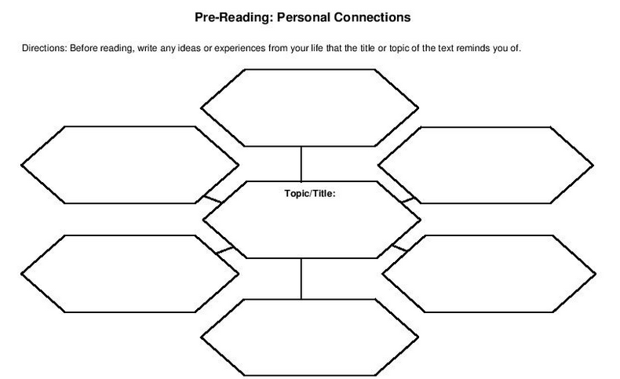
Titre / Thème :

Prédiction organisateur

Instructions: Avant de lire le texte, écrivez des prédictions sur le texte, le titre et les images. Complétez l’organisateur avant et après(after) la lecture.

Titre / Thème: ______________________________________________________________________
Avant(before) de lire
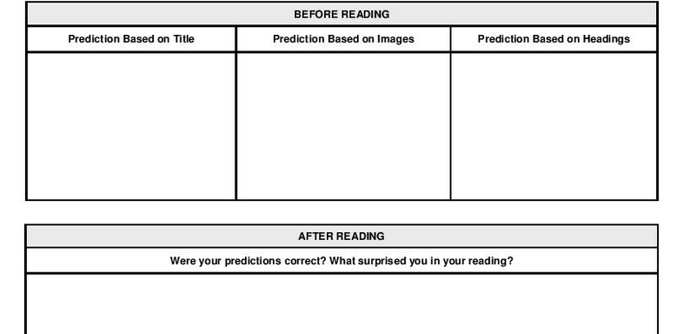
Prédictions basé sur lesintitulés(headings)
Prédictions basé sur les images
Prédictions basé sur le titre
Après (after) la lecture

et pistes
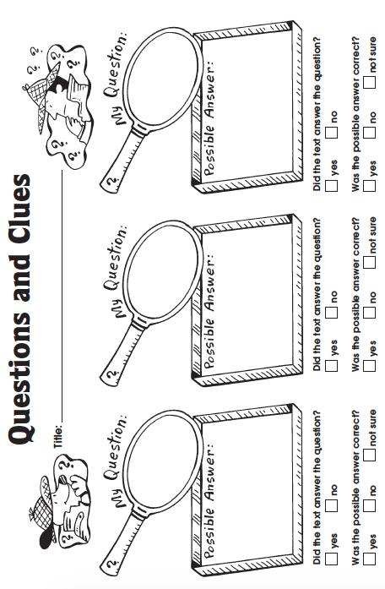
(clues)
non
non
non
non
oui
oui
oui
oui
pas sûr
pas sûr
pas sûr
oui
non
non
oui
Réponse possible :
Réponse possible :
Réponse possible :
Ma
Ma
Ma
Titre :
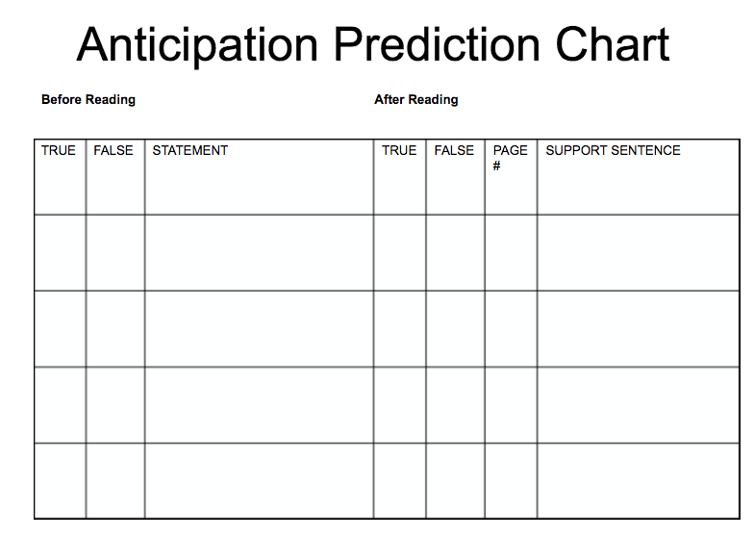
FAUX
FAUX
Instruction: écrivez des phrases avant(before) de lire. Write some predictions before reading. Check if you think they are true or false. While reading, note the page number, a sentence that prove that your previous prediction were either true or false.
Phrases avant de lire
Tableau d’Anticipation et Prédiction
PHRASE QUI PROUVE MON
HYPOTHÈSE. (Support sentence)
PAGE #
VRAI
VRAI

Avant la lecture
Après la lecture
Mon Thermomètre de Lecture

Avant de lire: Skim the text, looking at words and images, how much of the text do you think you understand before reading? Mark the gage before and after reading to measure how much of the text you understand.

Avant(before) de lire Après(after) la lecture
Check here: I can recognize cognates: ______ _______ I understand the text well enough to
summarize in French in sentence format.
I can recognize French words that I’ve learned _______ I understand the text, but can summarize or seen before: _____________ it in simple words and images.

90%

50%

20%

0-10%

0-

90%

50%

20%

0-10%

0-

